2021 Kings and Queens of the Ramp
Hosted by Manukau Outrigger Canoe Club
Saturday 14th Aug 2021
The Ramp, Ian Shaw Park, Mt Wellington

High tide 11.38am
8km - W6 Junior, Novice
14km - W6 Open, Mixed, Senior Master, GMM

Race Programme;

7.00 am : Arrive, Rigging, Registration
Nga Hau Maiangi Building, The Ramp, Ian Shaw Park

7.45 am : Safety checks commence

8.15 am : Race Briefing - 8km W6
9.00 am : Race Start - 8km W6

9.45 am : Race Briefing - 14km W6 Race
10.30 am : RACE START - 14km W6 all grades

12.00 pm : End of day and hot soup

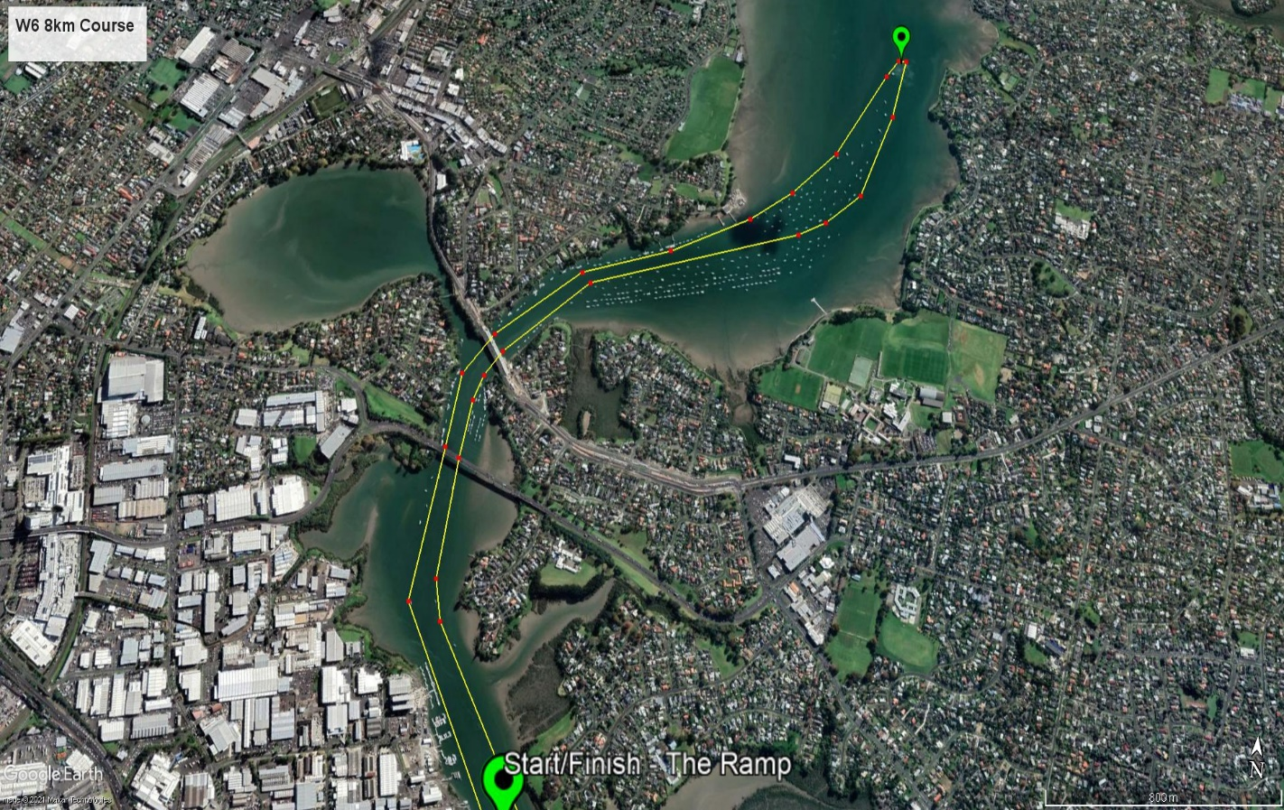

8km race course:
- Start in front of the pontoons at the Ramp.
- Head north following the channel past the two bridges
- Ama turn at the last green pole channel marker
- Head back N/E towards Tamaki wharf staying to the RIGHT- hand side of the channel
- Past the two bridges keeping to the RIGHT – hand side of the channel
- Finish back at the Pontoons keeping to the RIGHT – hand side of the channel

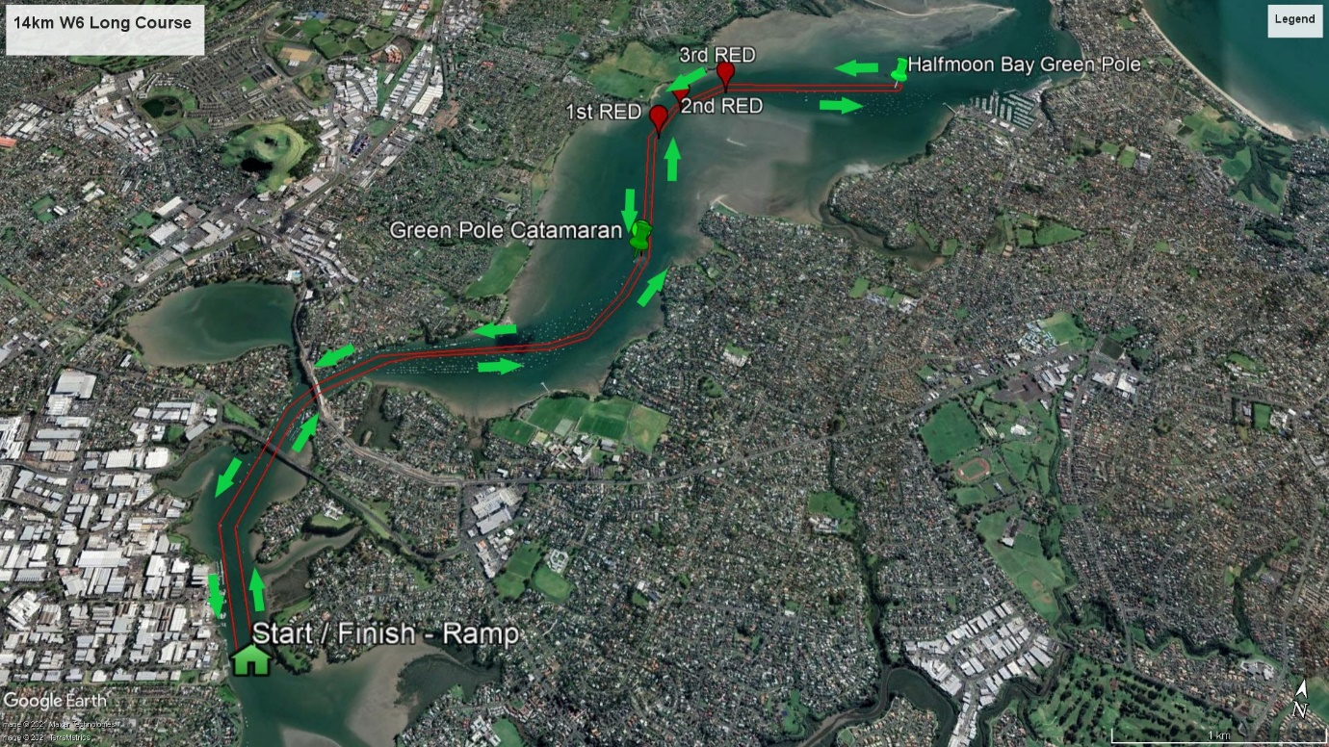
14km race course:
- Start in front of the pontoons at The Ramp
- Head north past the two bridges
- Follow the channel markers then ama turn at the Half Moon Bay channel marker

- Head back N/E towards Tamaki wharf staying to the RIGHT- hand side of the channel
- Past the two bridges, keeping to the RIGHT – hand side of the channel
- Keeping to the RIGHT – hand side of the channel, finishing back at the The Ramp pontoons.

